**Storage- Application Insight**

Create One Storage Account:

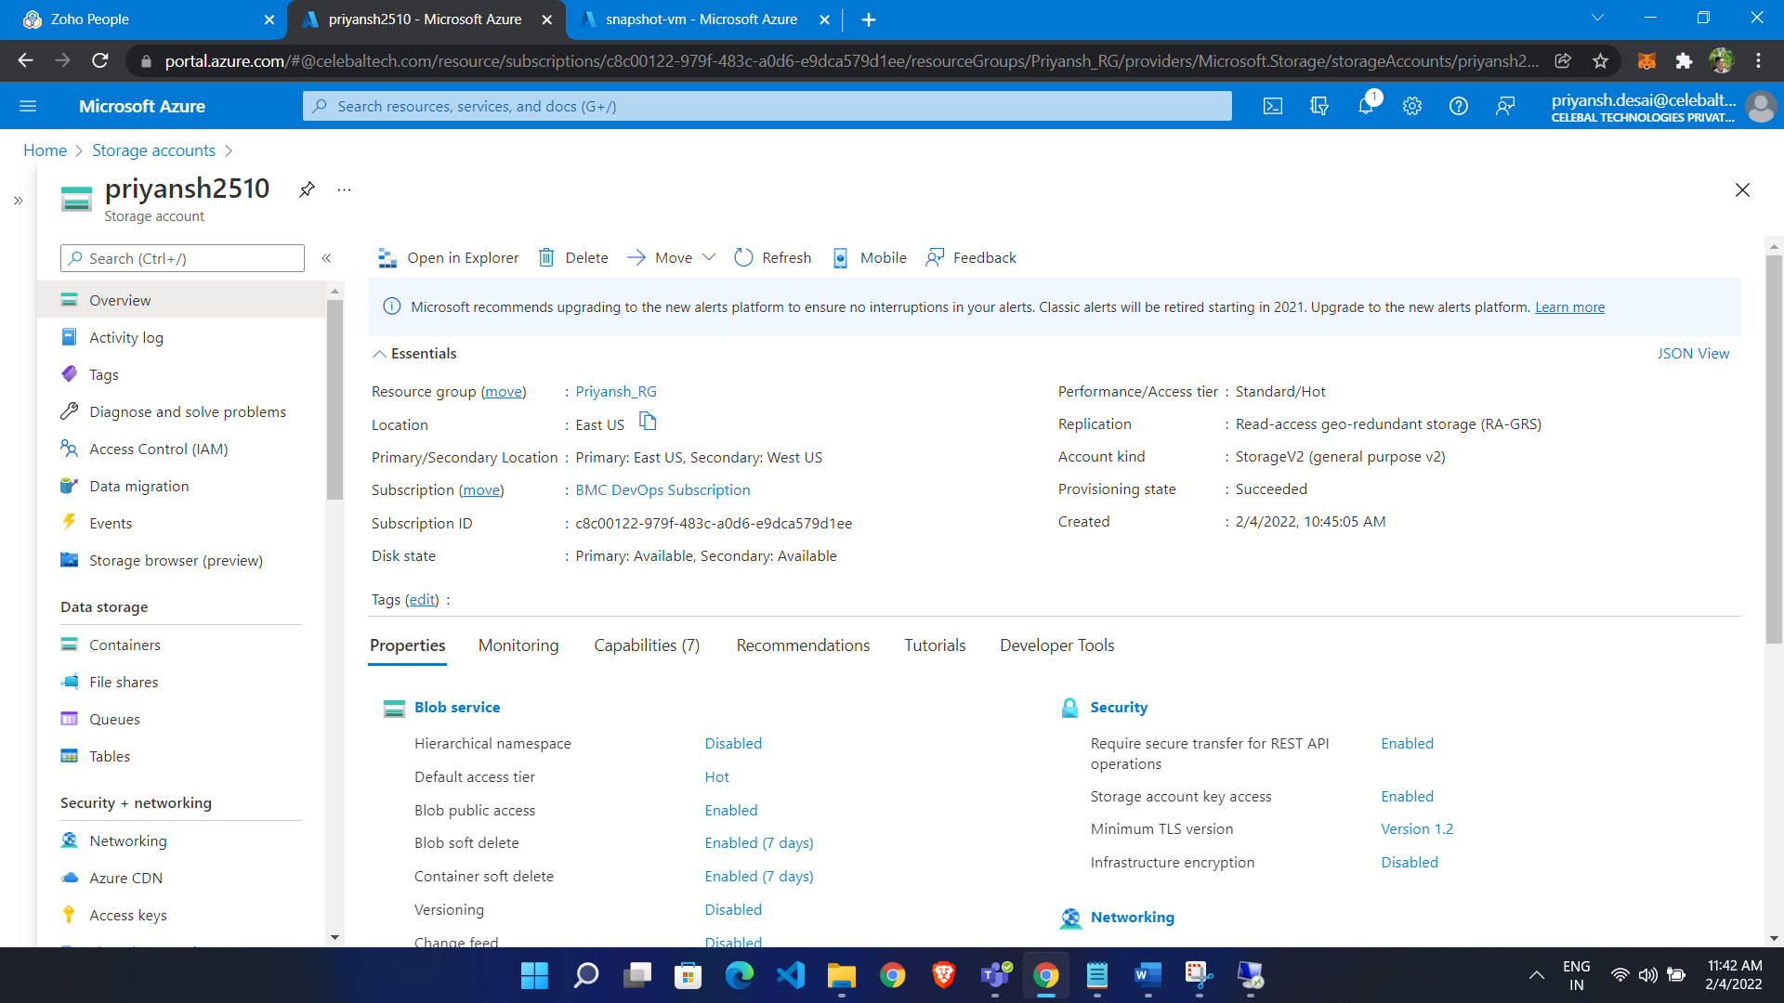

Now enable static Website:

* In left pane of storage account
* Click on static website
* Click enable
* Give index file name

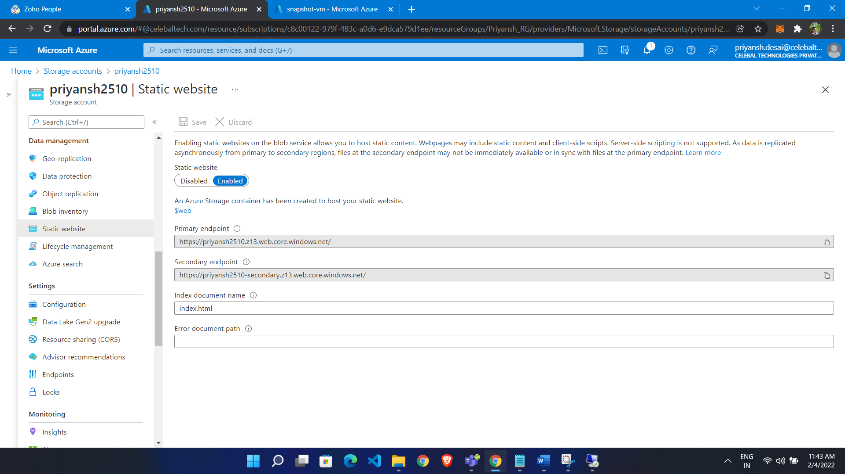

It will Give you URL

Now in container we see $web container

Upload our file there

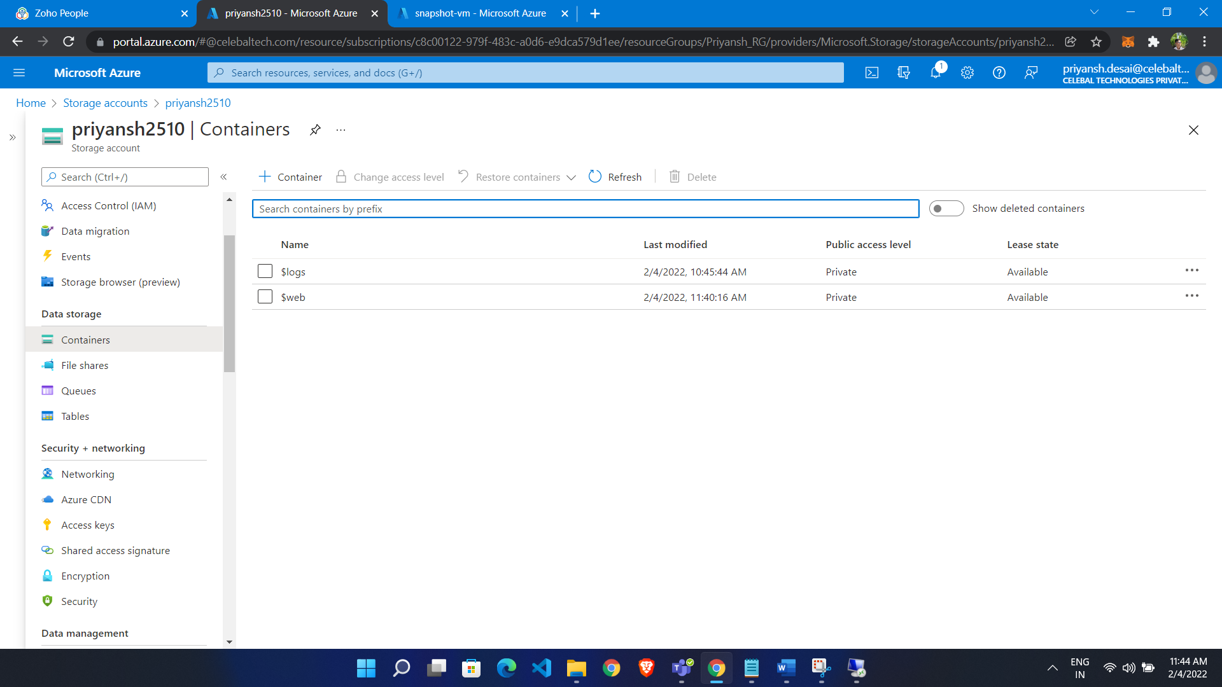

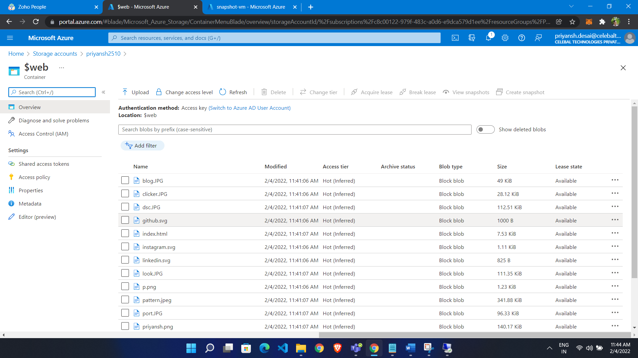

Now we are able to access static website via URl



Configure Application Insight:

* Search for Application Insight
* Click create
* Give resource Group
* Add name
* Click create

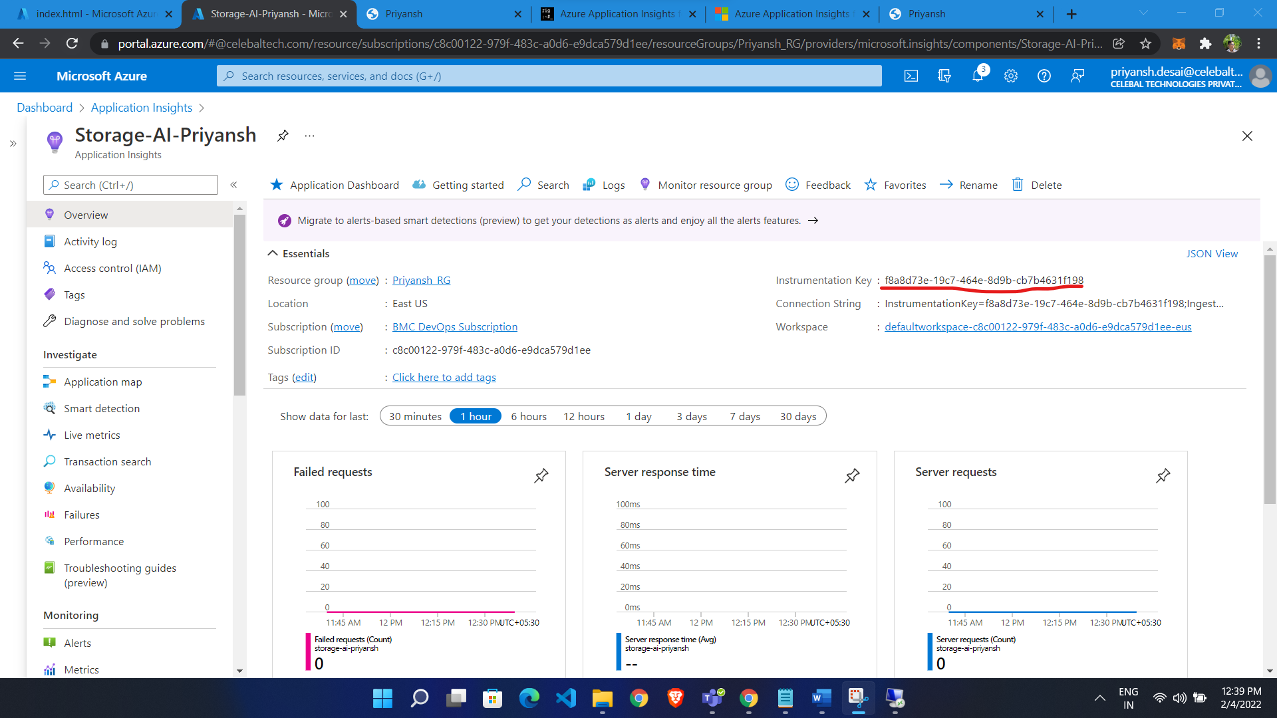

Copy Instrumental key and paste in script

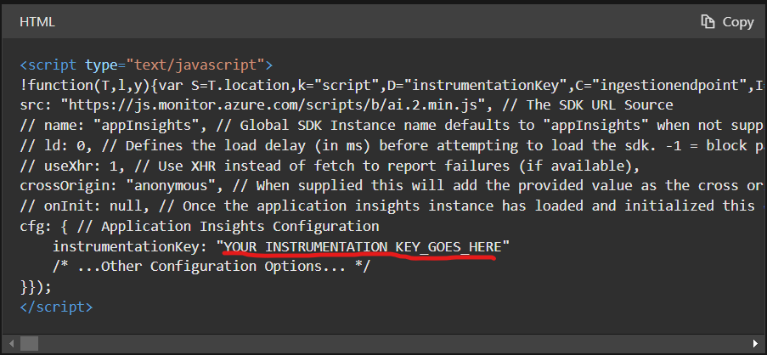

Script: [https://docs.microsoft.com/en-us/azure/azure-monitor/app/javascript#snippet-based-setup](https://docs.microsoft.com/en-us/azure/azure-monitor/app/javascript%23snippet-based-setup)

Add in your website

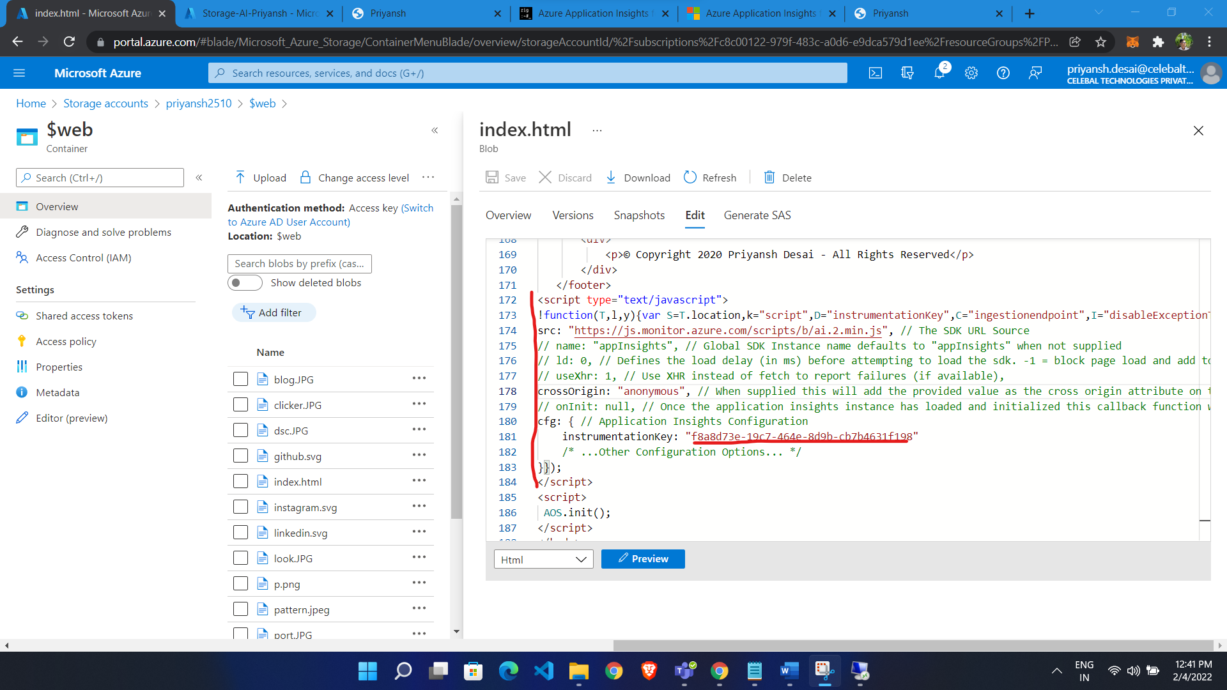

Now we are able to Monitor Performance

Choose browser

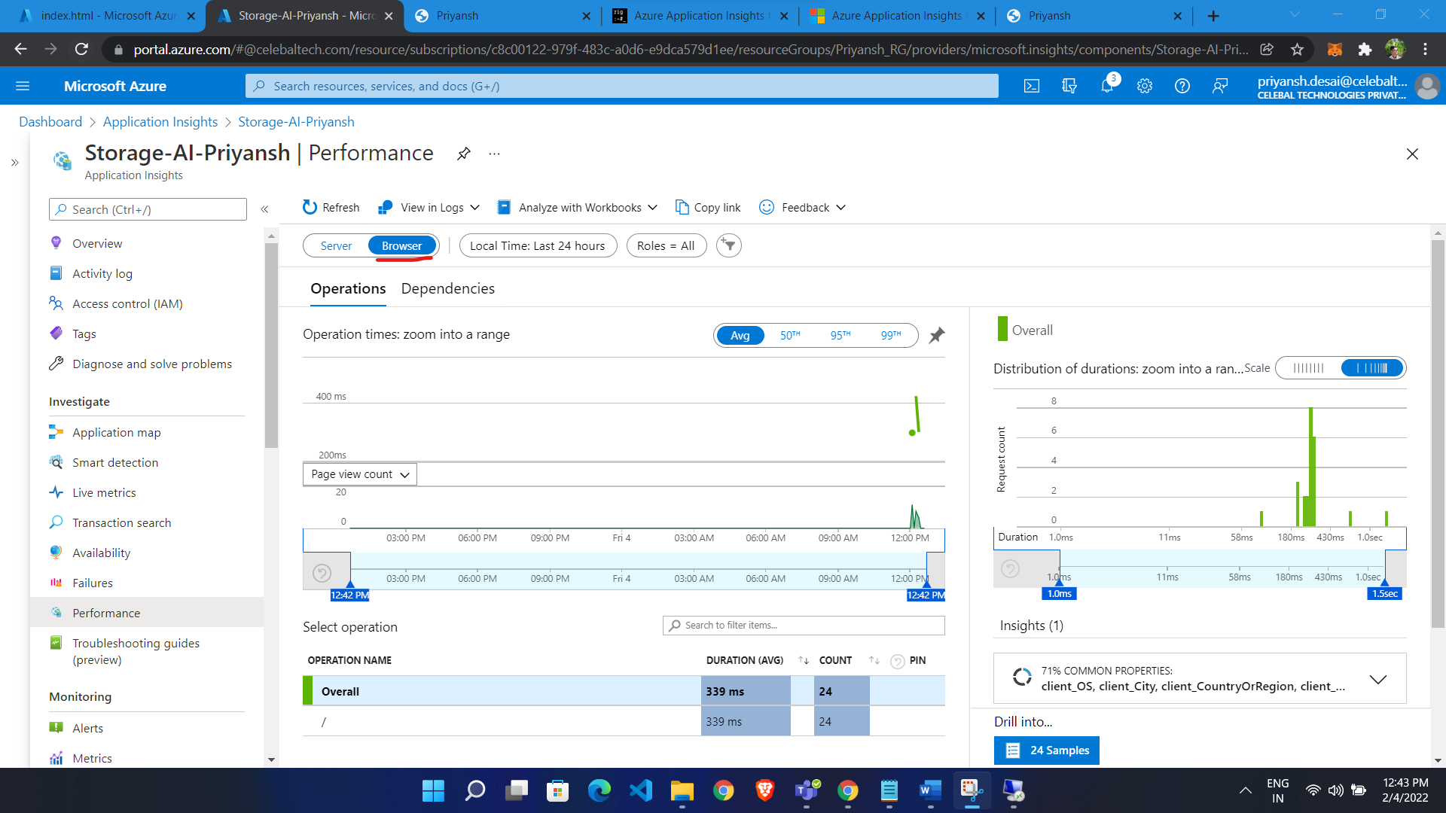

Dashboard:

